Project Design Phase-II
Data Flow Diagram & User Stories

Date | 26 March 2025
Team ID | SWTID1744544274
Project Name | Book-Store
Maximum Marks | 4 Marks

Data Flow Diagrams:
A Data Flow Diagram (DFD) is a traditional visual representation of the information flows within a system. A neat and clear DFD can depict the right amount of the system requirement graphically. It shows how data enters and leaves the system, what changes the information, and where data is stored.
DFD Level 0 (Industry Standard)
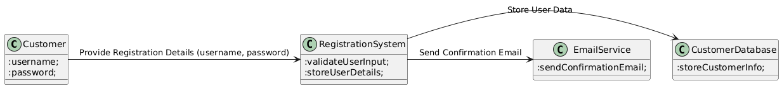

FLOW Diagram
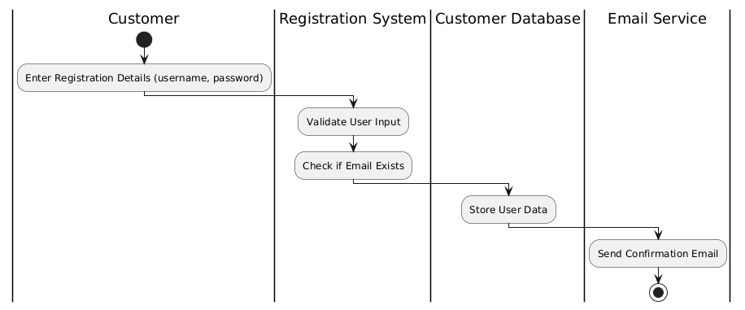

User Stories Table
User Type | Functional Requirement (Epic) | User Story Number | User Story / Task | Acceptance Criteria | Priority | Release
Customer (Mobile User) | Registration | USN-1 | As a user, I can register for the application by entering my email, password, and confirming my password. | I can access my account/dashboard after successful registration. | High | Sprint-1
Customer (Mobile User) | Registration | USN-2 | As a user, I will receive a confirmation email once I have registered for the application. | I can receive a confirmation email and click confirm to verify. | High | Sprint-1
Customer (Mobile User) | Registration | USN-3 | As a user, I can register for the application through Facebook. | I can register & access the dashboard with Facebook Login. | Low | Sprint-2
Customer (Mobile User) | Registration | USN-4 | As a user, I can register for the application through Gmail. | I can register & access the dashboard with Gmail Login. | Medium | Sprint-1
Customer (Mobile User) | Login | USN-5 | As a user, I can log into the application by entering my email & password. | I can successfully login to my account after providing valid details. | High | Sprint-1
Customer (Web User) | Dashboard | USN-6 | As a web user, I can view my personal dashboard displaying my orders, wish list, and recommended books. | The dashboard displays my personal data (orders, wish list, etc.) | High | Sprint-1
Customer (Web User) | Dashboard | USN-7 | As a web user, I can search for books using filters such as genre, price range, and author. | I can filter books based on criteria such as genre, price, etc. | High | Sprint-2
Customer Care Executive | User Management | USN-8 | As a customer care executive, I can view customer details and assist with account issues or queries. | I can access user details and provide support as required. | Medium | Sprint-2
Customer Care Executive | Order Management | USN-9 | As a customer care executive, I can view customer orders and assist in tracking or modifying them. | I can search, view, and track customer orders in the system. | Medium | Sprint-2
Administrator | Admin Dashboard | USN-10 | As an administrator, I can manage users, products, and view reports for sales and user activity. | I can manage user accounts, products, and view analytics. | High | Sprint-3
Administrator | Product Management | USN-11 | As an administrator, I can add, update, or delete products from the catalog. | I can modify the product catalog by adding, updating, or removing products. | High | Sprint -3

